|  |  |  |
| --- | --- | --- |
| SCHOOL OF INFORMATION AND TECHNOLOGY | | |
| NAME: Hyra Cayambas, Dale Matthew Boquiren | DATE PERFORMED: 11/27 | /50 |
| Section: IDC1 | DATE SUBMITTED: 12/04 |

# SYSADM1 – Capacity Management & Planning

**Part 2. Network Scalability Analysis**

Recall the e-commerce website scenario we discussed earlier. Given the expected surge in traffic, analyze the provided network topology diagram. Identify potential bottlenecks and areas where scalability might be a concern. Propose specific strategies to improve the network's scalability and performance to ensure a seamless user experience during the peak traffic period. Consider factors such as increased user demand, new applications, and security threats.

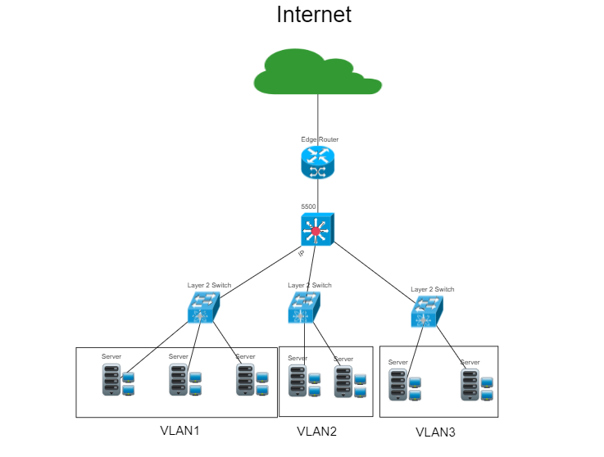

**Proposed Diagram:**

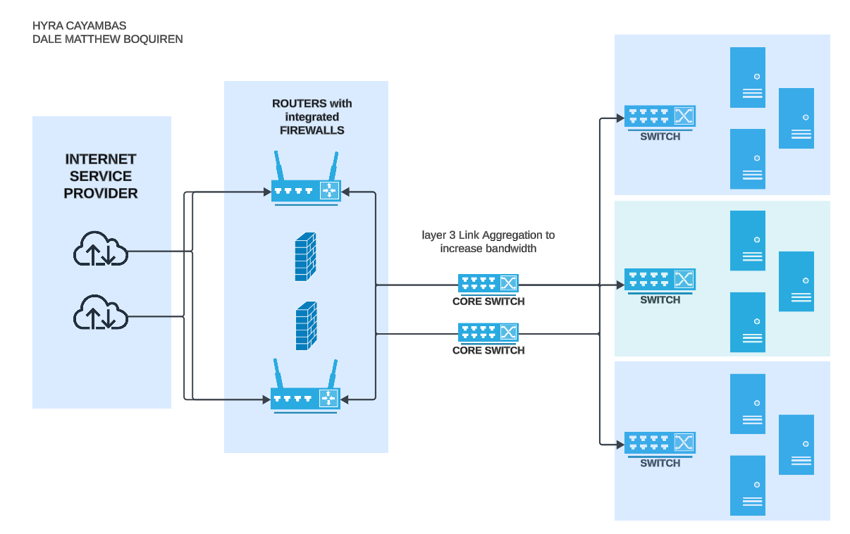

**Network Analysis**

**Potential Bottlenecks:**

1. **Bandwidth Limitations:** Insufficient bandwidth could result in delays during peak traffic, especially for multimedia-rich content.
2. **Overloaded Servers:** A single server or limited cluster of servers handling requests might become a bottleneck.
3. **Data Flow Through Firewalls:** If firewall rules are not optimized for high traffic, they could slow down data processing.
4. **Single Points of Failure:** Centralized systems, such as databases or key infrastructure nodes, may pose risks.
5. **Latency in CDN Usage:** Poorly configured Content Delivery Networks (CDNs) might result in higher latency for users in certain geographic locations.

**Security Risks:**

1. **DDoS Attacks:** High traffic may mask distributed denial-of-service attacks, straining resources.
2. **Outdated Security Protocols:** Insufficient encryption or outda ted security mechanisms could expose the network to breaches.
3. **Unauthorized Access:** Weak access controls might lead to unauthorized usage during peak periods.

**Scalability Planning**

1. **Network Optimization**:
   * **Layer 3 Link Aggregation**: Enhancing bandwidth capacity by bundling multiple links ensures faster data flow and fault tolerance between core switches and access layers.
   * **Firewall Load Balancing**: Distribute incoming traffic across multiple firewalls to prevent bottlenecks during traffic surges.
2. **Hardware Scalability**:
   * **Modular Switches**: Use modular core switches to allow future expansion without replacing existing equipment.
   * **Redundant Links**: Add more redundant paths between routers, firewalls, and switches to improve fault tolerance and scalability.
3. **Traffic Management**:
   * **Quality of Service (QoS)**: Prioritize critical applications, ensuring that high-priority traffic receives bandwidth during peak loads.
   * **Dynamic Routing Protocols**: Implement protocols like OSPF or BGP to optimize routing and prevent delays.
4. **Security Enhancements**:
   * **Deep Packet Inspection (DPI)**: Deploy advanced firewalls capable of DPI for better threat detection and management.
   * **Distributed Denial of Service (DDoS) Protection**: Integrate DDoS mitigation systems to handle unexpected malicious traffic.
5. **Server Expansion**:
   * Cluster servers in the access layers for load balancing and failover capabilities.
   * Introduce virtualized environments (e.g., VMware, Hyper-V) for scalable computing.

**Evaluation of Solutions**

1. **Proposed Scalability Solutions**:
   * **Link Aggregation**: Bundling links between core switches improves data throughput and provides redundancy, ensuring seamless scalability during high demand.
   * **Modular Hardware**: Core and access switches with modular designs enable cost-effective expansion, ensuring the network can grow with user demands.
   * **Firewall Enhancements**: Distributing traffic across multiple firewalls reduces bottlenecks and improves resilience.
2. **Benefits**:
   * **Performance Boost**: Layer 3 Link Aggregation and QoS ensure smooth traffic flow, even during peak periods.
   * **Redundancy**: Redundant paths and modular hardware reduce the risk of system failures.
   * **Future-Proofing**: Scalability strategies allow for incremental upgrades without overhauling the entire network.
3. **Potential Drawbacks**:
   * **Initial Costs**: Upgrading to modular hardware and adding firewalls might increase upfront expenses.
   * **Configuration Complexity**: Dynamic routing protocols and advanced QoS policies require expert configuration and monitoring.
4. **Justification**:
   * The proposed network design is a robust, scalable, and future-proof solution that balances performance, security, and cost. Layer 3 Link Aggregation and modular switches enable seamless scalability and bandwidth growth. Redundant links and firewalls improve reliability by eliminating single points of failure, ensuring uninterrupted service during failures or attacks. Advanced security measures, such as Deep Packet Inspection (DPI) and DDoS mitigation, protect the network from evolving threats. While the upfront costs are significant, the design minimizes long-term expenses through modular upgrades and reduced downtime. Its industry-standard components ensure compatibility and ease of implementation, while the architecture supports future expansion without major overhauls, making it a justified and comprehensive solution

|  |  |  |  |
| --- | --- | --- | --- |
| Criteria | Excellent | 10pts | Good | 7pts | Needs Improvement | 4pts |
| **Network Analysis** | Accurately identifies potential bottlenecks, security risks, and capacity limitations. | Identifies key network components and some potential bottlenecks. | Identifies some basic network components but lacks a comprehensive analysis. |
| **Scalability Planning** | Proposes multiple relevant solutions and provides detailed explanations, including potential drawbacks and benefits. | Proposes some relevant scalability strategies but lacks detail. | Proposes limited scalability strategies. |
| **Evaluation of Solutions** | Proposes comprehensive scalability strategies, including specific recommendations for hardware upgrades, software configurations, and network optimizations. | Provides a basic evaluation of the proposed solutions, but lacks depth. | Does not evaluate the proposed solutions or provides a superficial evaluation. |
| **Proposed Design** | Provides a detailed and well-justified design, including network diagrams, configuration details, and implementation plans. | Provides a basic design but lacks specific details and justifications. | Does not provide a clear and detailed design. |
| **Evaluation and Justification** | Provides a thorough evaluation of the proposed solutions, considering factors like cost, complexity, and potential impact. | Provides a basic evaluation of the proposed solutions, but lacks depth. | Does not evaluate the proposed solutions or provides a superficial evaluation |
| Score: | | | /50 |